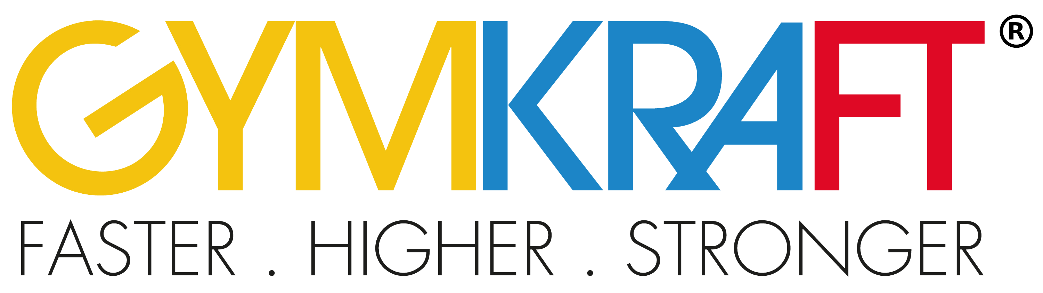

GYMKRAFT
CHEER FEST
2018
________
REGISTRATION
PACKAGE
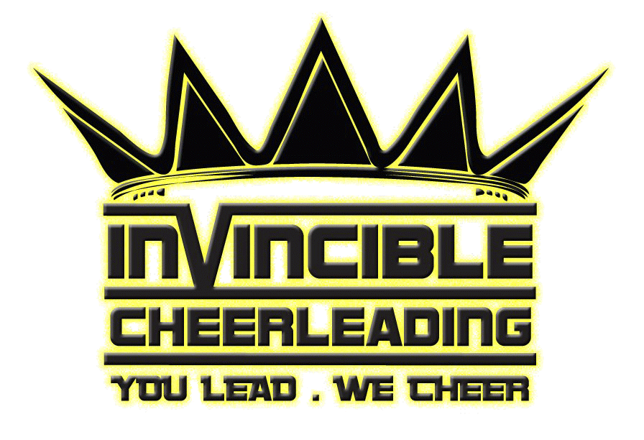
Organised by Invincible Cheerleading
Supported by Cheerleading Association (Singapore)

SUBMITTING THE REGISTRATION PACKAGE
Please complete all of the forms in the registration package and submit the excel document via email to events@invinciblecheer.com
Please use the following subject header: “GYMKRAFT CHEER FEST 2018 Registration” for the email.

RELEASE AND INDEMNITY FORM
All participants are required to submit the attached “Release and Indemnity Form” (or download via www.invinciblecheer.com) in order to be eligible to compete for the competition. For participants aged below 18, the forms are to be submitted by a parent/legal guardian.

PAYMENT
Registration fee per division are as follows:
Division | Rules Reference | Age of Participants | Team Size | Registration Fees*
Co-ed Partner Stunt | Premier | 15 years or older | 2 athletes | SG$40
Co-ed Group Stunt | Premier (Restricted) | 15 years or older | Max. 5 athletes | SG$100
Co-ed Small Team | Elite | 15 years or older | Max. 12 athletes | SG$240

*Registration fees applies for each category, regardless of cross-over.
Please submit payment via electronic transfer to:
Account Name: Invincible Cheerleading
Bank Name: DBS Bank
Account Number: 020-901770-2
Please furnish a screenshot with the transaction reference number during submission of your registration.
All payments must be made and received by the registration deadline (7 October 2018).

GYMKRAFT CHEER FEST 2018
Contact Information Form
All information and updates regarding the competition will be sent to the following contact person:
CONTACT INFORMATION
Name of Contact Person
Salutation
Date of Birth
Email Address
Contact Number

CONFIRMATION
By sending in this registration package, the contact person and all mentioned persons in the registration package confirm that they have read and understood the rules and policies that apply to the competition and that they accept them. The contact person must also inform all their participants and involved personnel about the rules and policies. By sending in the registration package, the contact person also confirms that they have reviewed the competition rules with all participants and all involved personnel that they accept them as a fair and integral part of the competition and agree to adhere to the rules, policies and procedures contained herein. The contact person confirms and declares that all submitted information is true and complete.

INDEMNITY AND RELEASE FORM
By signing up and using GymKraft's facilities and services, you have agreed to the following Acknowledgement, Waiver and Release from Liability Agreement.

Please complete the indemnity and waiver form via the link below:
http://bit.ly/GKCF2018form

GYMKRAFT CHEER FEST 2018
Contact Information Form
Please key in your team name and the division (Co-ed Partner Stunt, Co-ed Group Stunt, Co-ed Small Team) your team is participating in.
Please key in the Athlete’s Name as stated in official documents ( no alias nor nicknames), Gender, Date of Birth in DD-MMM-YYYY format (e.g. 05-Jan-2000), and NRIC/FIN Number.
Note: Crossovers are allowed between division. Each athlete may not represent more than one team within the same division.TEAM AND ATHLETES INFORMATION

